ICO TOKEN SALE

TEAM 4 : PROSPER,VASANTH,SUSHWANTH,HAMEED

Done through truffle framework :

The Truffle language implementation framework is an open source library for building tools and programming languages implementations as interpreters for self-modifying Abstract Syntax Trees. Together with the open source  Graal Compiler , Truffle represents a significant step forward in programming language implementation technology in the current era of dynamic languages.

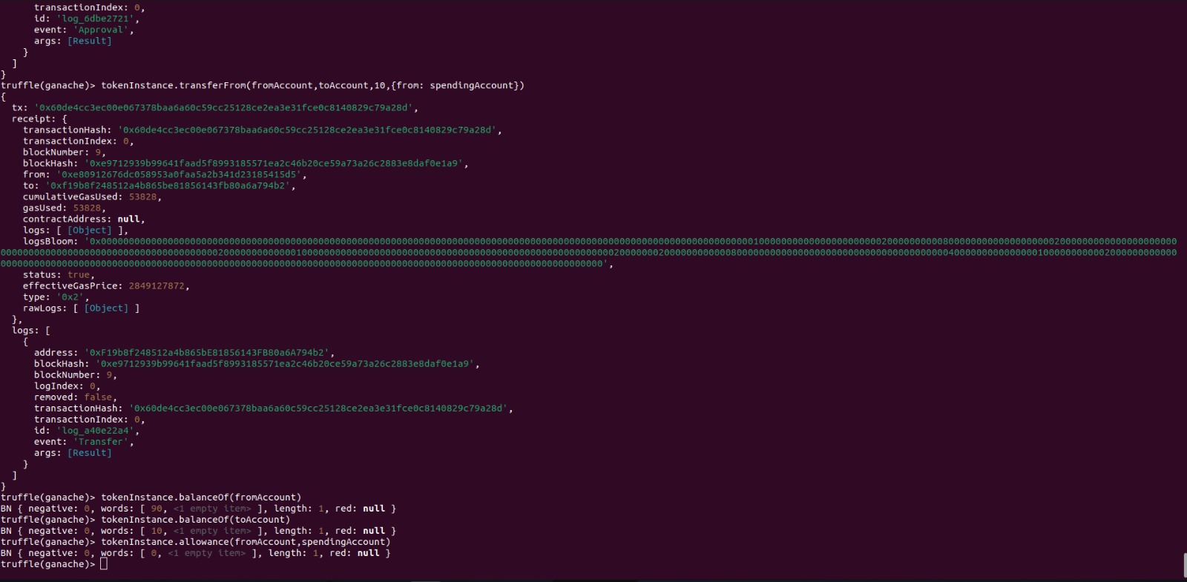

During the token sale, participants can use their chosen cryptocurrency or token to purchase your DApp tokens. The smart contract will handle the purchase process, including the distribution of tokens to buyers.

### WhatsApp Image 2023-07-07 at 6.21.21 AM

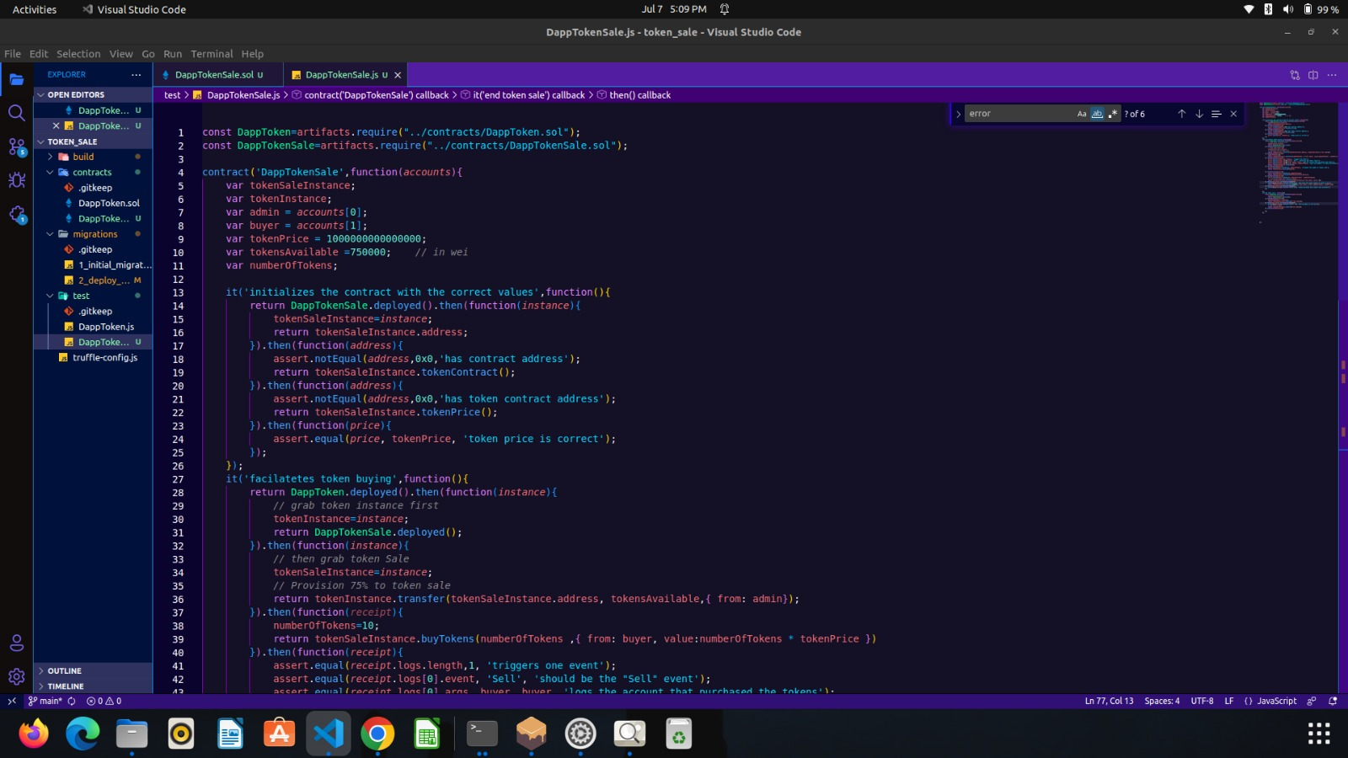

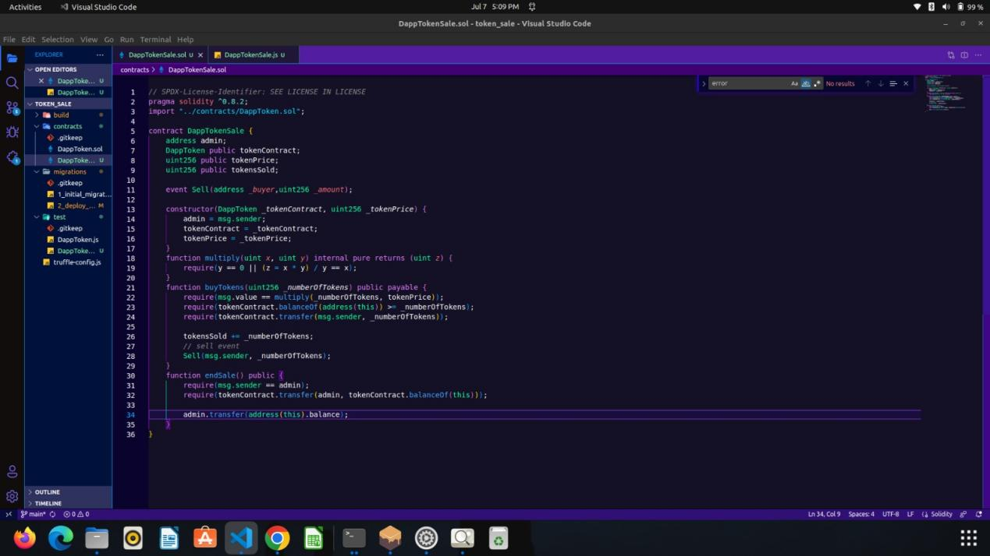

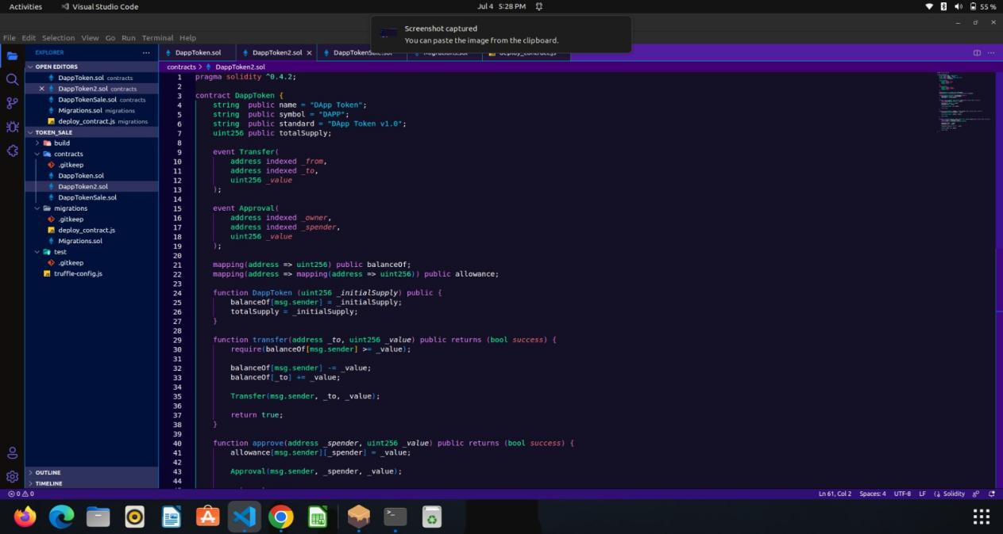

MIGRATION :

Migrations are JavaScript files that help you deploy contracts to the Ethereum network. These files are responsible for staging your deployment tasks, and they're written under the assumption that your deployment needs will change over time.

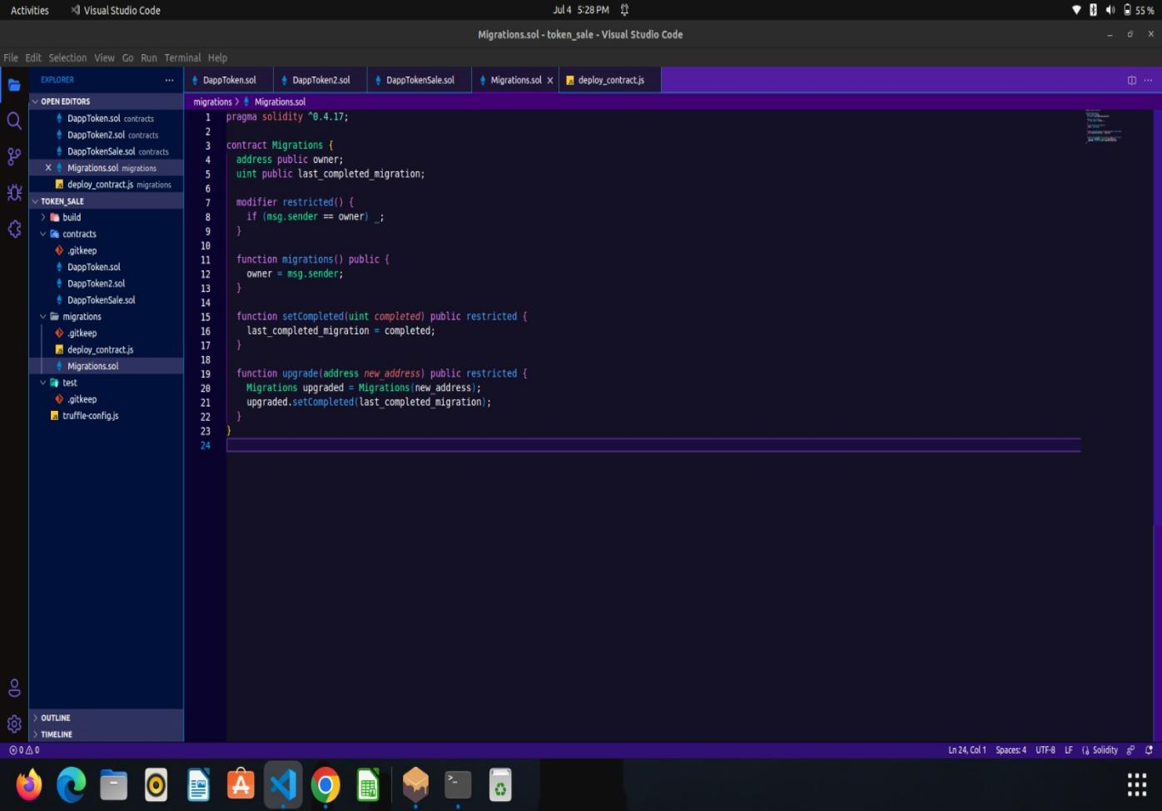

TOKEN SALE :

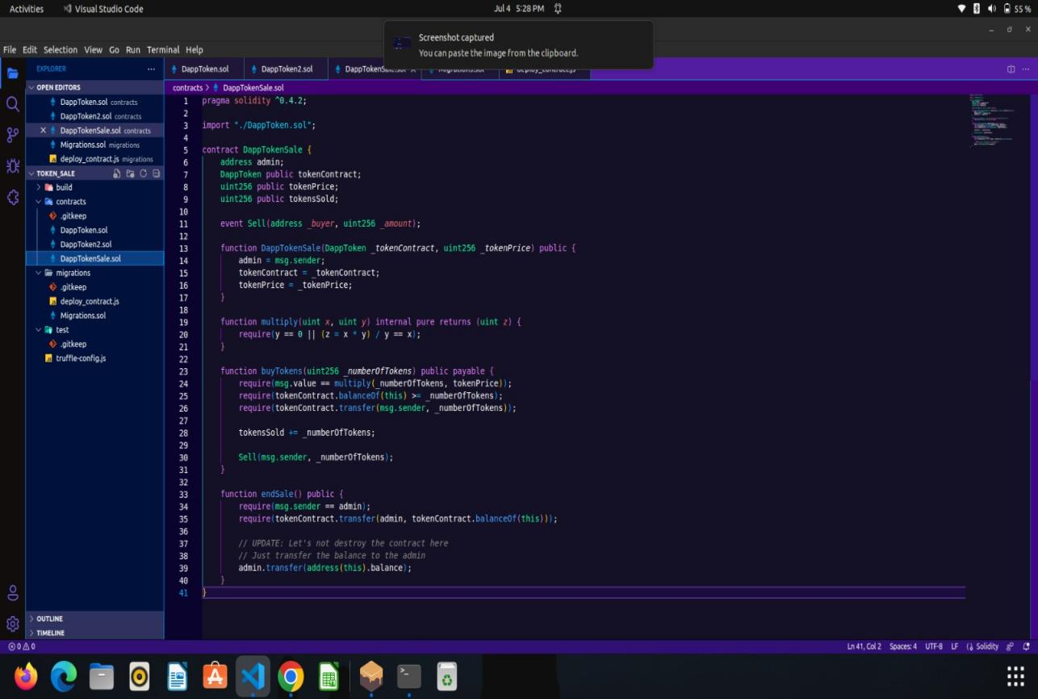

We have deployed the token which is running on the local host

This is the scrrenshot of

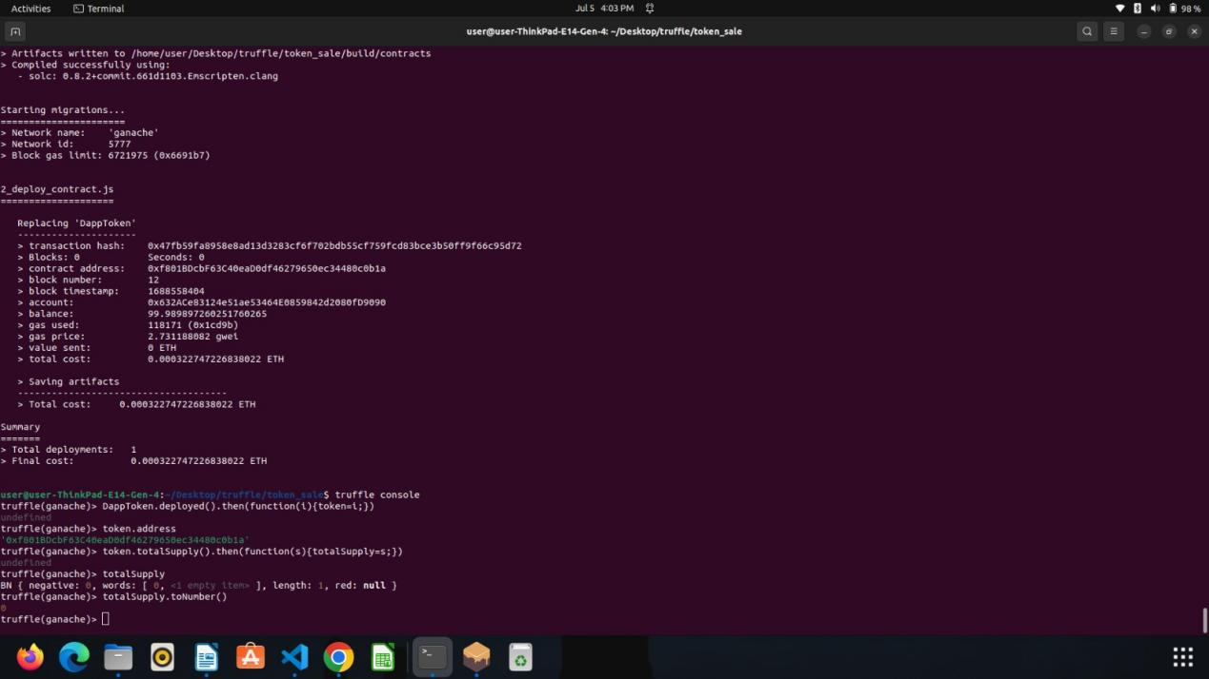

This is the migration process

